Flip-Flop Applications
Flip-flops are used in a variety of application circuits, the most common among these being the frequency division and counting circuits and data storage and transfer circuits. Both these applications use a cascaded arrangement of flip-flops with or without some additional combinational logic to perform the desired function.
Counters and registers belong to the category of MSI sequential logic circuits. They have similar architecture, as both counters and registers comprise a cascaded arrangement of more than one flip-flop with or without combinational logic devices. Both constitute very important building blocks of sequential logic, and different types of counter and register available in integrated circuit (IC) form are used in a wide range of digital systems. While counters are mainly used in counting applications, where they either measure the time interval between two unknown time instants or measure the frequency of a given signal, registers are primarily used for the temporary storage of data present at the output of a digital circuit before they are fed to another digital circuit. We are all familiar with the role of different types of register used inside a microprocessor, and also their use in microprocessor-based applications. Because of the very nature of operation of registers, they form the basis of a very important class of counters called shift counters.

Ripple (Asynchronous) Counter
A ripple counter is a cascaded arrangement of flip-flops where the output of one flip-flop drives the clock input of the following flip-flop. The number of flip-flops in the cascaded arrangement depends upon the number of different logic states that it goes through before it repeats the sequence, a parameter known as the modulus of the counter. In a ripple counter, also called an asynchronous counter or a serial counter, the clock input is applied only to the first flip-flop, also called the input flip-flop, in the cascaded arrangement. The clock input to any subsequent flip-flop comes from the output of its immediately preceding flip-flop. For instance, the output of the first flip-flop acts as the clock input to the second flip-flop, the output of the second flip-flop feeds the clock input of the third flip-flop and so on. In general, in an arrangement of n flip-flops, the clock input to the nth flip-flop comes from the output of the (n−1)^{th} flip-flop for n>1. The figure below shows the generalized block schematic arrangement of an n-bit binary ripple counter.

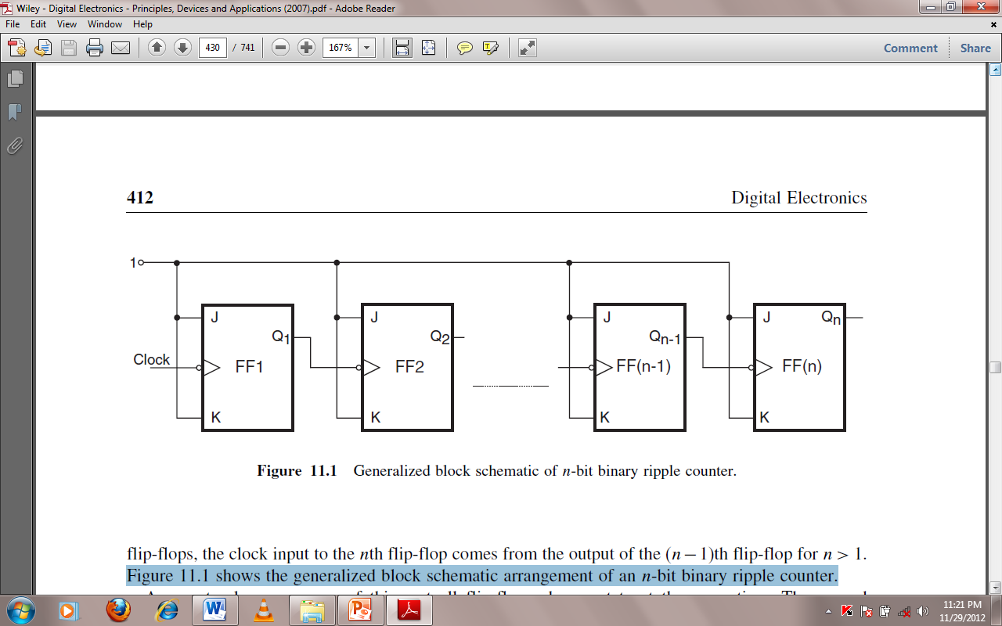

Modulus of a Counter
The modulus (MOD number) of a counter is the number of different logic states it goes through before it comes back to the initial state to repeat the count sequence. An n-bit counter that counts through all its natural states and does not skip any of the states has a modulus of 2n. We can see that such counters have a modulus that is an integral power of 2, that is, 2, 4, 8, 16 and so on. These can be modified with the help of additional combinational logic to get a modulus of less than 2n. To determine the number of flip-flops required to build a counter having a given modulus, identify the smallest integer m that is either equal to or greater than the desired modulus and is also equal to an integral power of 2. For instance, if the desired modulus is 10, which is the case in a decade counter, the smallest integer greater than or equal to 10 and which is also an integral power of 2 is 16. The number of flip-flops in this case would be 4, as 16 = 2⁴. On the same lines, the number of flip-flops required to construct counters with MOD numbers of 3, 6, 14, 28 and 63 would be 2, 3, 4, 5 and 6 respectively.

The figure below shows a four-bit ripple counter implemented with negative edge-triggered J-K flip-flops wired as toggle flip-flops. The output of the first flip-flop feeds the clock input of the second, and the output of the second flip-flop feeds the clock input of the third, the output of which in turn feeds the clock input of the fourth flip-flop. The outputs of the four flip-flops are designated as Q0 (LSB flip-flop), Q1, Q2 and Q3 (MSB flip-flop). The other figure shows the waveforms appearing at Q0, Q1, Q2 and Q3 outputs as the clock signal goes through successive cycles of trigger pulses.
The counter functions as follows.
Let us assume that all the flip-flops are initially cleared to the ‘0’ state. On HIGH-to-LOW transition of the first clock pulse, Q0 goes from ‘0’ to ‘1’ owing to the toggling action. As the flip-flops used are negative edge-triggered ones, the ‘0’ to ‘1’ transition of Q0 does not trigger flip-flop FF1. FF1, long with FF2 and FF3, remains in its ‘0’ state. So, on the occurrence of the first negative-going clock transition, Q0 = 1, Q1 = 0, Q2 = 0 and Q3 = 0.
On the HIGH-to-LOW transition of the second clock pulse, Q0 toggles again. That is, it goes from ‘1’ to ‘0’. This ‘1’ to ‘0’ transition at the Q0 output triggers FF1, the output Q1 of which goes from ‘0’ to ‘1’. The Q2 and Q3 outputs remain unaffected. Therefore, immediately after the occurrence of the second HIGH-to-LOW transition of the clock signal,
Q0 = 0, Q1 = 1, Q2 = 0 and Q3 = 0. On similar lines, we can explain the logic status of Q0, Q1, Q2 and Q3 outputs immediately after subsequent clock transitions. The logic status of outputs for the first 16 relevant (HIGH-to-LOW in the present case) clock signal transitions is summarized the Table shown. Thus, we see that the counter goes through 16 distinct states from 0000 to 1111 and then, on the occurrence of the desired transition of the sixteenth clock pulse, it resets to the original state of 0000 from where it had started. In general, if we had N flip-flops, we could count up to 2N pulses before the counter resets to the initial state. We can also see from the Q0, Q1, Q2 and Q3 waveforms, as shown
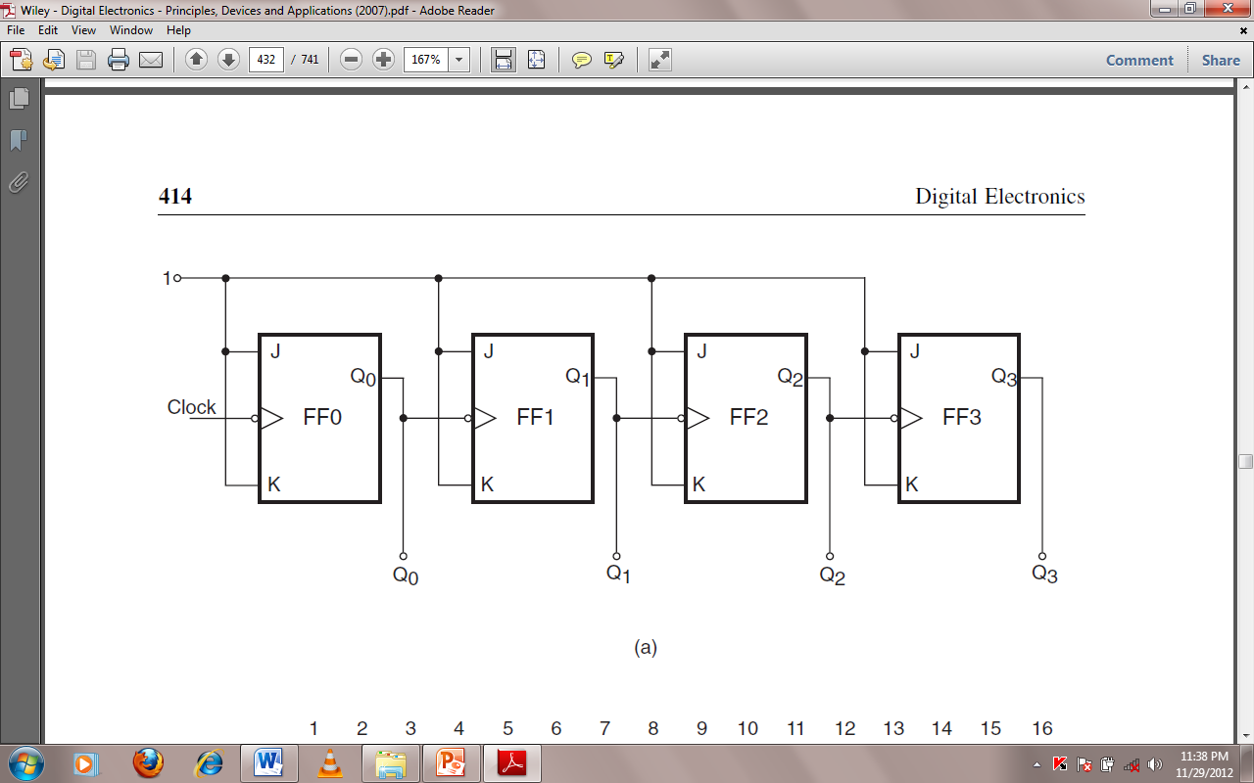

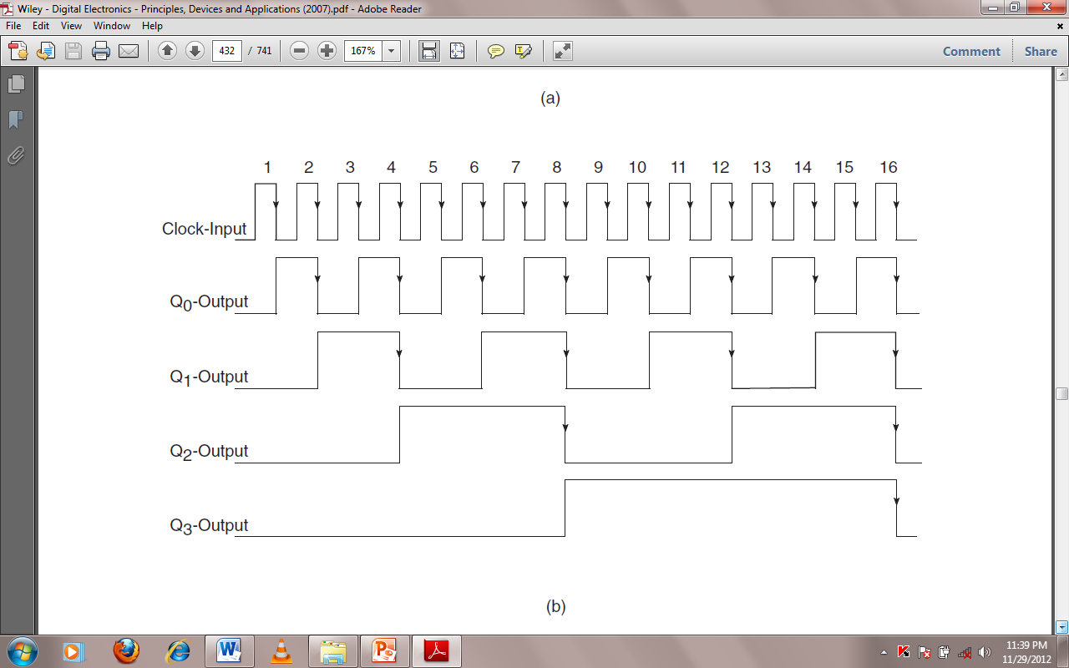

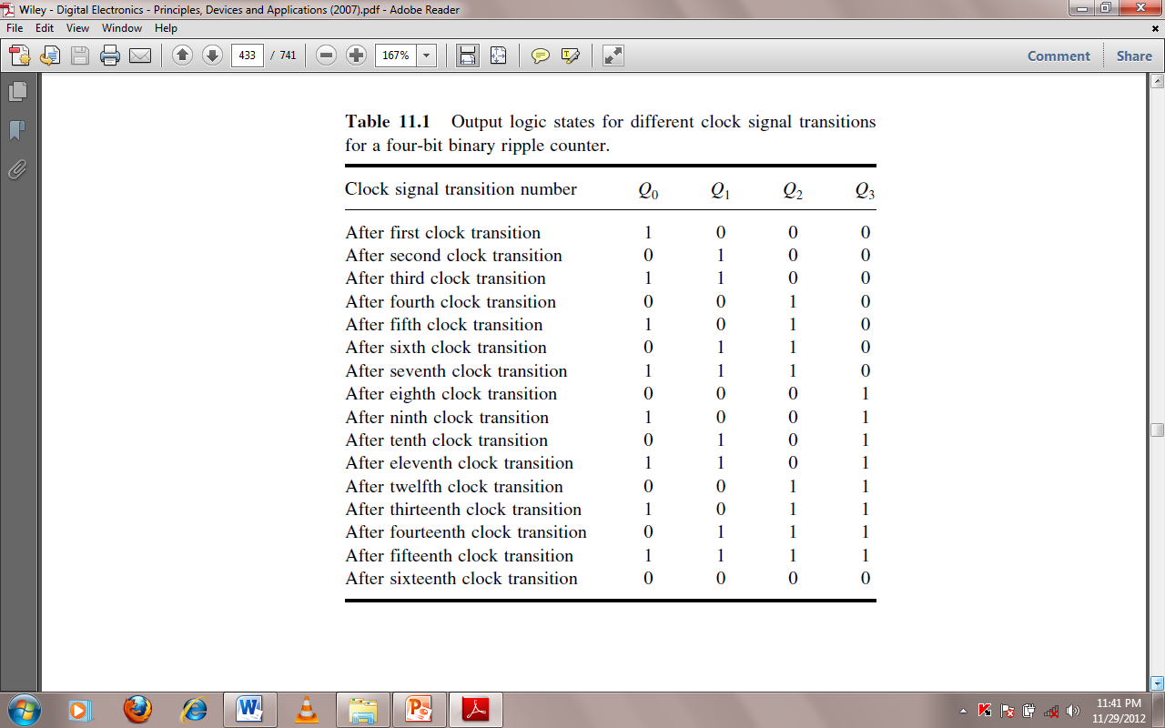
Shift Register
A shift register is a digital device used for storage and transfer of data. The basic building block in all shift registers is the flip-flop, mainly a D-type flip-flop. The storage capacity of a shift register equals the total number of bits of digital data it can store, which in turn depends upon the number of flip-flops used to construct the shift register. Since each flip-flop can store one bit of data, the storage capacity of the shift register equals the number of flip-flops used.
Based on the method used to load data onto and read data from shift registers, they are classified as serial-in serial-out (SISO) shift registers, serial-in parallel-out (SIPO) shift registers, parallel-in serial-out (PISO) shift registers and parallel-in parallel-out (PIPO) shift registers.
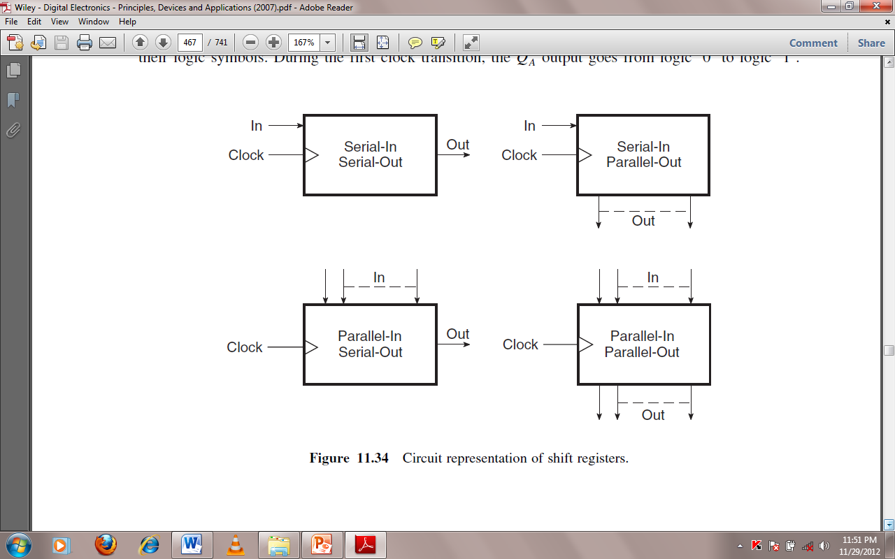

Serial-In Serial-Out Shift Register
The figure below shows the basic four-bit serial-in serial-out shift register implemented using D flip-flops. The circuit functions as follows. A reset applied to the CLEAR input of all the flip-flops resets their Q outputs to 0s. Refer to the timing waveform. The waveforms shown include the clock pulse train, the waveform representing the data to be loaded onto the shift register and the Q outputs of different flip-flops.
The flip-flops shown respond to the LOW-to-HIGH transition of the clock pulses as indicated by their logic symbols. During the first clock transition, the QA output goes from logic ‘0’ to logic ‘1’.

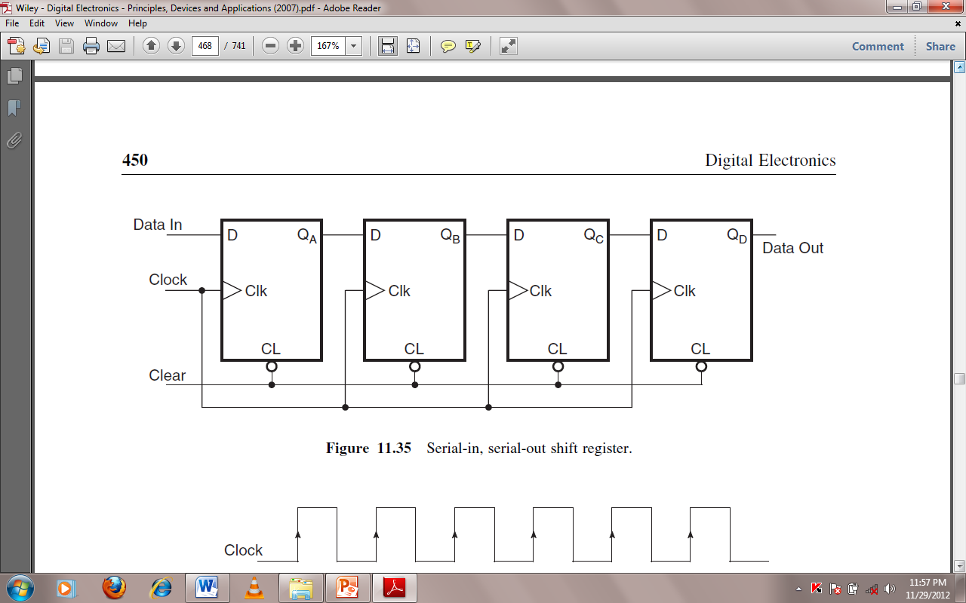

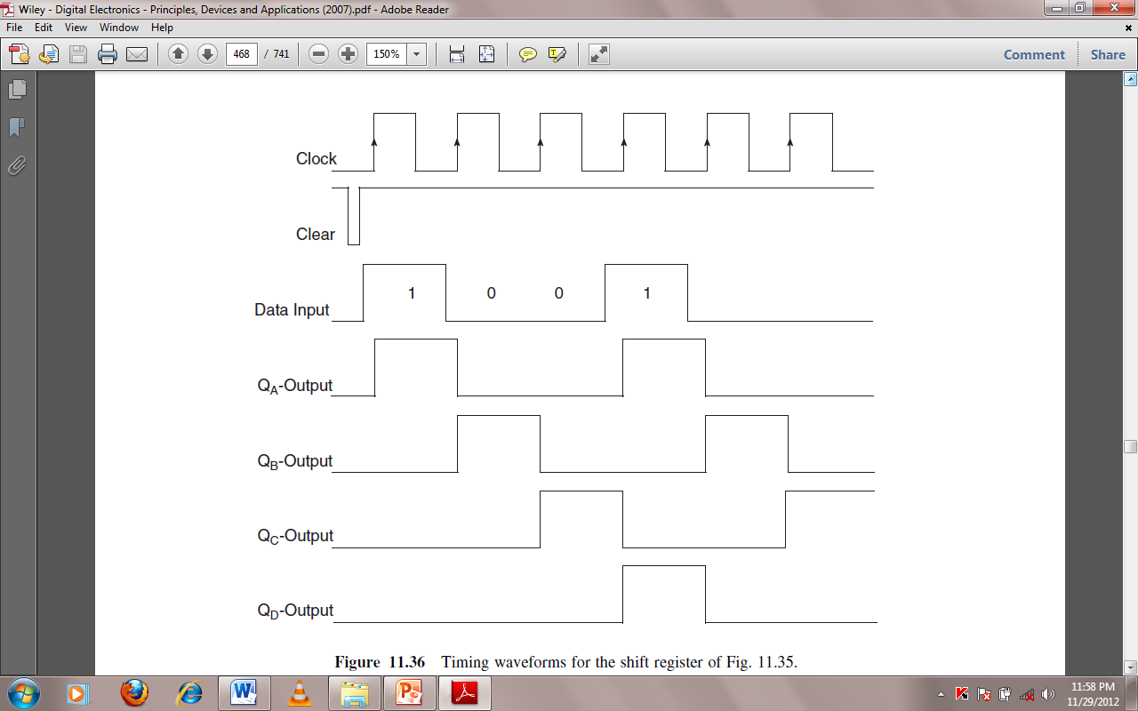
The outputs of the other three flip-flops remain in the logic ‘0’ state as their D inputs were in the logic ‘0’ state at the time of clock transition. During the second clock transition, the QA output goes from logic ‘1’ to logic ‘0’ and the QB output goes from logic ‘0’ to logic ‘1’, again in accordance with the logic status of the D inputs at the time of relevant clock transition.
Thus, we have seen that a logic ‘1’ that was present at the data input prior to the occurrence of the first clock transition has reached the QB output at the end of two clock transitions. This bit will reach the QD output at the end of four clock transitions
